NEWPORT PAGNELL HERITAGE TRAIL
WALK ONE
Newport’s origins as a burgh are considered to be late Saxon, i.e. 10th century. The name Newport implies ‘new market town’.
Newport appears in the Doomsday Book as a manor and later passed into the Paynel family which gives us Pagnell.
The manor passed down through various families over the centuries and was even owned by the Crown at one point until in 1819 the manor was split up and further enclosures took place.
Fortunately one of the major assets Bury Field escaped this fate and still today has common rights held by older properties in the town.
The medieval town was formed along the High Street joined roughly midway by St Johns Street. Other important streets at this time and still in existence were Mill Street, Union Street, Silver Street, Church Passage and Ousebank/Riverside, once known as Dungeon Lane.
It was a flourishing market town and the area called Market Hill shows this. During the English Civil War it was an important area. There was a Benedictine priory called Tickford Priory until 1542.
Newport had canal and a railway as well as being a coaching town. It is famous for lace and parchment making as well as having the last used iron bridge in the country and being the home of car making.

WALK BEGINNING
We begin this walk at THE NORTH BRIDGE and THE NORTH BRIDGE TOLL HOUSE. (To get to the toll house use the left side of the road footpath).
This bridge is a single span stone bridge, which allowed horse-drawn vehicles to pass in and out of town. Originally there was a ford at this point, and then later a timber bridge stood alongside the ford. This wooden bridge was rebuilt in stone around 1380 and was made up of three arches. It survived until 1810, when the present North Bridge was built. A single arch of the 14th century bridge can still be seen in Ousebank Gardens.
In the process of putting together the planning for the building of the present bridge authority was given to build a toll house with gates near the bridge to take tolls from anyone wishing to cross with vehicles or animals. The money raised was to pay costs incurred by the bridge. There was initially a temporary building. The present bridge was completed in 1809 and carries this date on the keystone of the arch on its west face. The present toll house was built. The bridge has undergone repairs since. In 1837 gas was used for lighting on the bridge instead of oil thanks to a gas works in the town. The front bay window of the toll house was used as a lookout so that no potential toll collection was missed.

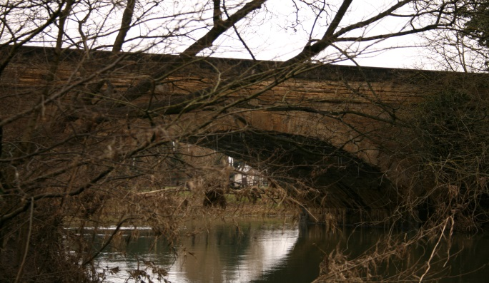
The North Bridge

Collecting tolls on the bridge was eventually stopped, so the Toll House was no longer needed. Instead of demolishing it, it was sold to a Miss Beaty on condition it was only to be used as a private dwelling and not a business. The next owner, William Bateman Bull, was allowed to make an opening in the North Bridge wall near the House to make a road into the field beside it. This can still be used. In 2010 the bridge celebrated its bicentennial.

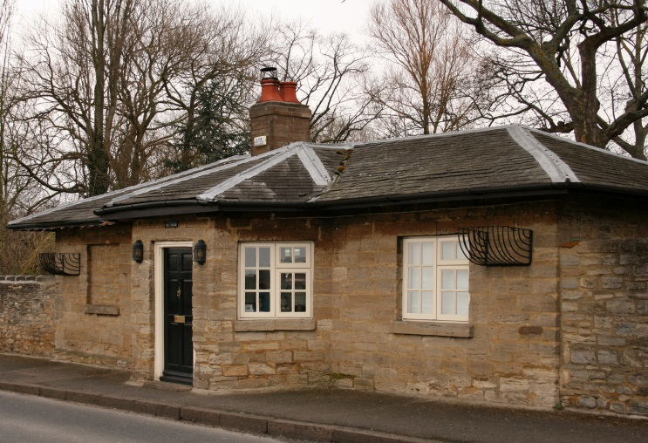
The Toll House

Next we move onto THE ROYAL BRITISH LEGION BUILDING. In the late 17th century a large red brick building with a tiled roof and dormer windows was built on the site where an ancient manor house was once situated. This brick building stood away from the road and was surrounded by a brick wall. Its address was number 2 Ousebank Street, but it was also called Brooklands House.
It has over time been a private girls’ school, the town’s public library as well as being used as a doctor’s surgery.
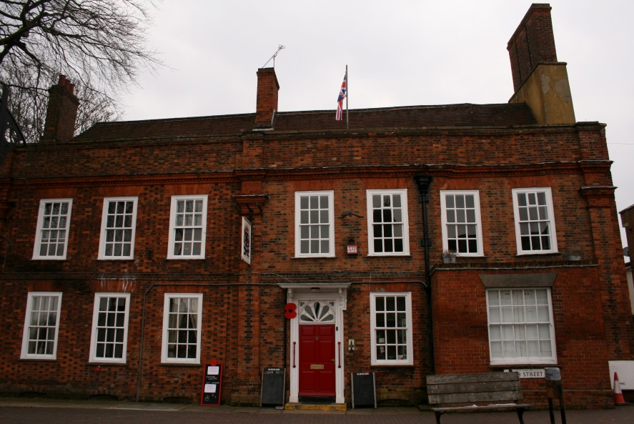 British Legion

In 1980 it became a centre for the Royal British Legion. The gardens of the building are now publicly owned and lead down to the river. The building is now also a club.
Next on our tour is the impressive parish church of St. Peter and St. Paul. lt was built in the 14th century. The tower was erected during the 16th century and the crenellations (battlements) and pinnacles added in 1827. Inside the Church the galleries were built on the North side in 1710 and South side in 1724. In 1866 local solicitor and Gent, Mr. George Cooch along with his sister Anne gave £500 for a new organ. The organ was fitted in August of that year and a brass plaque commemorates the gift. If you turn left by the north porch, the oldest part of the church, you will come across a row of alms houses, built in 1763 by John Revis a Charing Cross draper who made good in London. The church holds an early chained copy of John Foxe's Book of Martyrs. The book has celebrated its 450th anniversary. More pictures of the book are to be found on the church’s Flikr site.
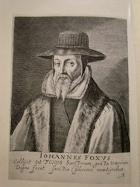
The church was listed in 1950, but lots of gravestones have been moved to form paths around the building. Further information is available inside the church.
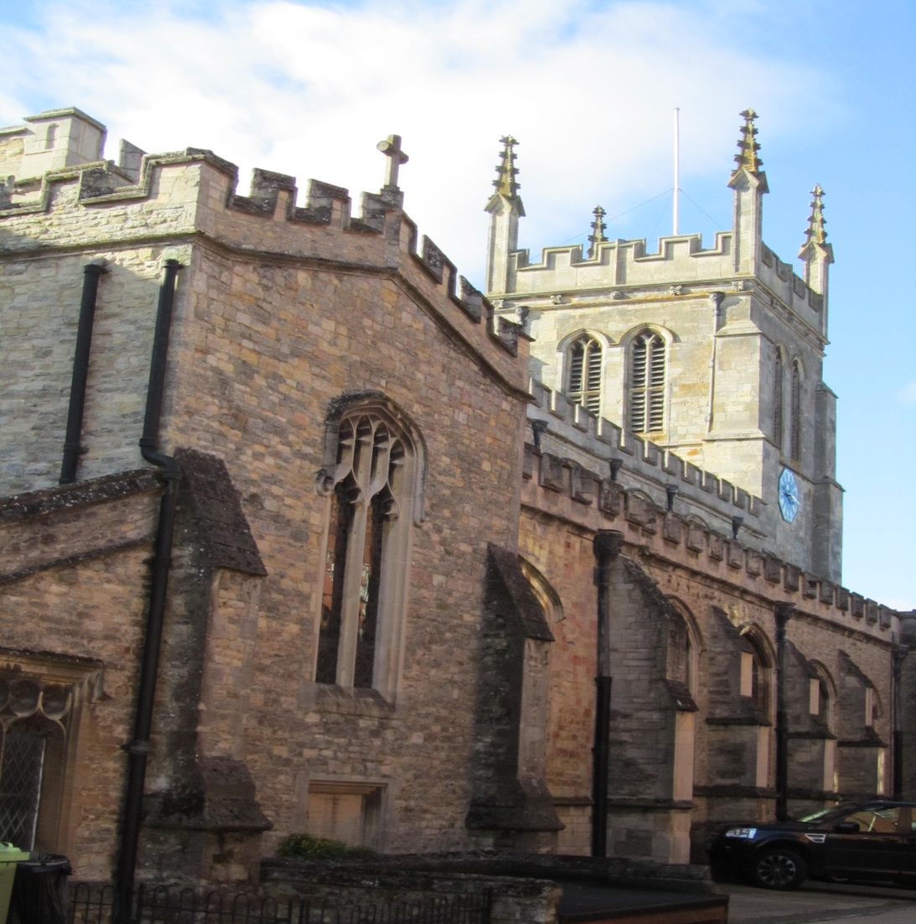

Walk past the alms houses along Church Passage and turn right as you approach Brooklands Centre. Just inside the cemetery you will find CEMETRY LODGE. The first thing to notice is that the building has a spire. It was built in 1860 by local architect Richard Sheppard and was used to carry out burials, being a chapel of rest.
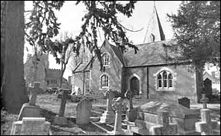
It is now a family home called Spire Cottage.

Now return back to the parish church along Church Passage. You will pass small monument. This monument commemorates the successful Newport Pagnell lace maker Thomas Abbott Hamilton, whose father John was also a lace maker. Newport Pagnell was the centre of the North Buckinghamshire lace trade. There is an epitaph carved into the top of the plinth by the famous local poet William Cowper of Olney, also a local lace making town. Cowper lived in the late 18th century. The plinth was erected in 1997.

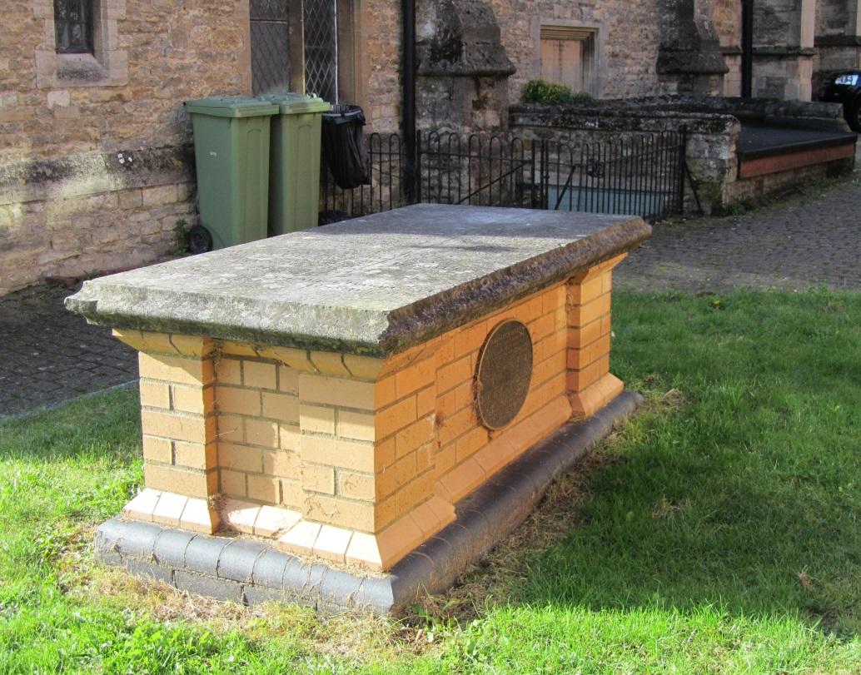

Further along Church Passage you will come to 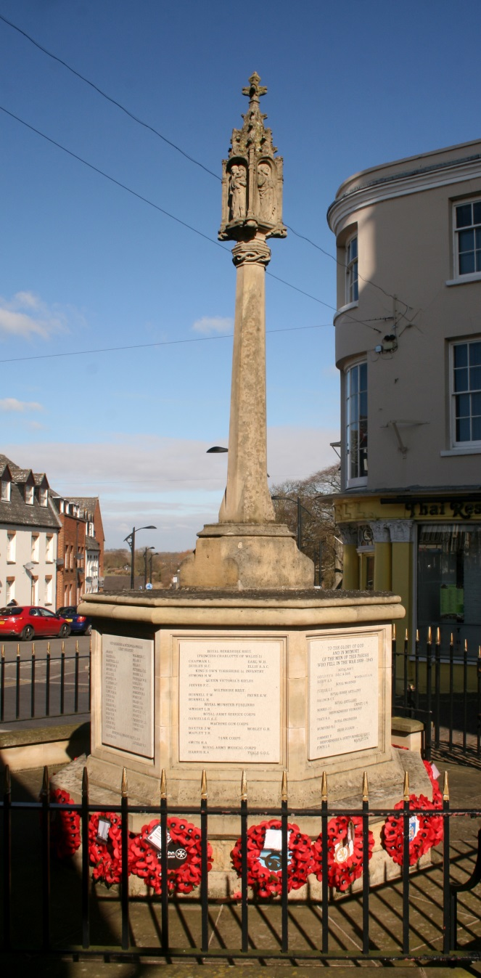
The War Memorial

Continue back to the High Street. Here you will find The Pin Petch Restaurant. This building was originally an ironmongers shop run by the Odell family. It is an early Victorian building that was for over 150 years an ironmongers with workshops. The Ironmongers closed in 1991 after which it has been a restaurant. There used to be a wonderful aroma in the old Odell premises and one was reminded of olden days before large commercial stores. An ancient well was discovered in the old shop which also contains several other unusual features. The old front step has worn after a century and a half of use and the entrance doors are curved. These were once covered with other solid mourning doors that were used during funerals at the Church. These old doors are on display at the town museum. It has a stucco front, Corinthian pillars and a parapet.
It is rumoured that the building was haunted by a ghost called Emily, who tragically burned to death, when her apron caught fire. She used to cook breakfasts for draymen, who delivered to The Ram pub opposite (now modern flats).
For more information on the Odell family go to www.mkheritage.co.uk/nphs.

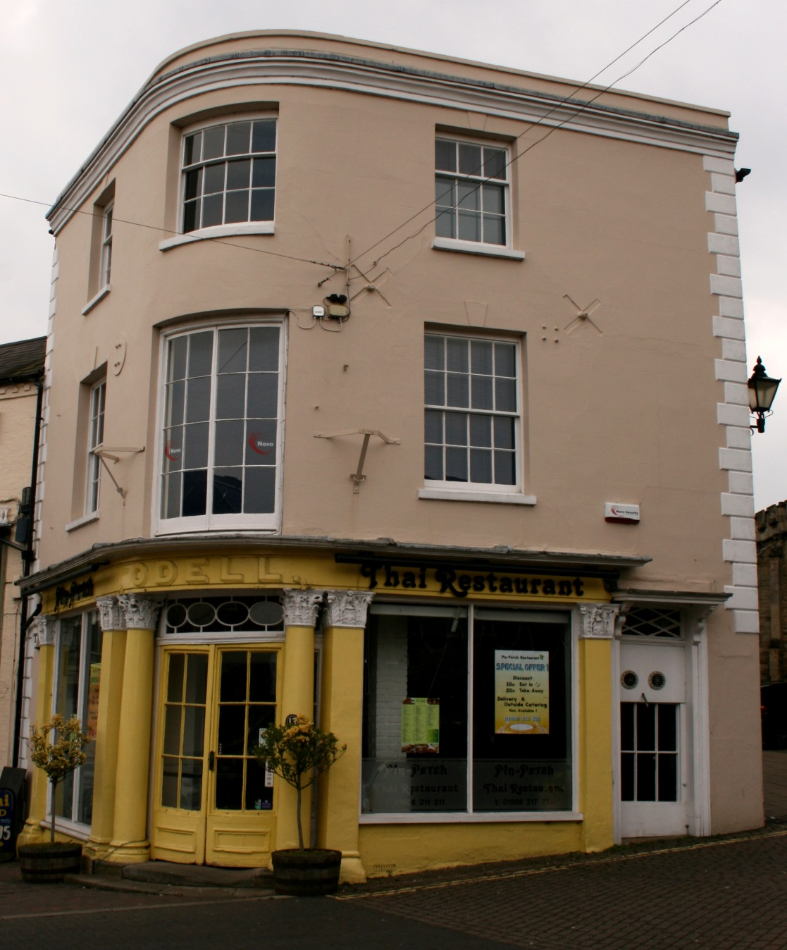
Pin Petch Restaurant formally Odells Ironmongers

Now look across the road and you will see a very grand building, now the POST OFFICE. In 1872 it was built for Bassett’s Bank, the oldest banking institution in Buckinghamshire. This building was designed and erected by local architect Edward Swinfen Harris. It later became Barclays Bank.
As you face the post office to your left is THE SWAN REVIVED. This building was a very early coaching inn, dating back to at least the very end of the 16th century. Coaches and carriages would drive through the arch on the left to the stables, which is now a car park. It was formerly The White Swan and it competed for many, many years with The Saracen’s Head Inn that stood next door. The Saracen’s Head was destroyed by fire in 1880. Inside The Swan Revived it has a mid 17th century staircase and an entrance hall supported by columns. In the 1820s The Swan Inn was updated with a Georgian frontage. The renovation included a new front entrance and the building became a hotel. It is a listed building. Electors once stood in front of the building as famous Prime Minister Benjamin Disraeli addressed them. Other famous people are connected with the inn including the famous diarist Samuel Pepys. Magistrates held sessions here for a time. It also said that artists in the past often paid for their board and lodgings by painting the inn sign.
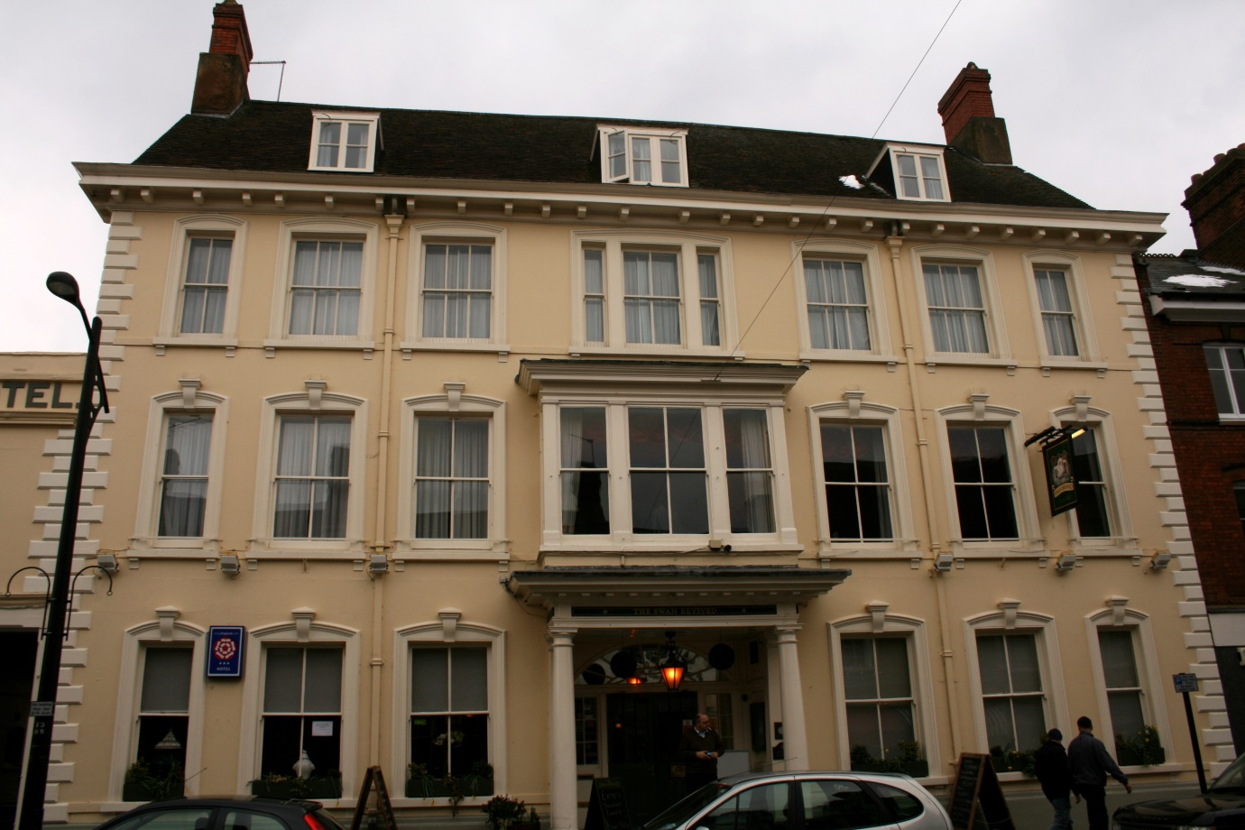

The Swan Revived

