NEWPORT PAGNELL TOWN COUNCIL PARK IMPROVEMENTS
Newport Pagnell Town Council have made improvements within the below parks with the assistance of some funding from Milton Keynes Council Community Infrastructure Fund 2024/25.
These are mainly for under surfacing works where the wetpour was no longer suitable to meet the criteria of EN standards.
The National Play Association does not recommend fencing in a play area around any parks unless these are right on top of a busy road, because fencing restricts the ability to run (an essential element of play) and also because fencing can itself pose a safety risk to children. Accordingly, the fence around the play area at Lakes Lane has been removed.
We have also added a new slide at Whitethorns Park which I hope you will agree is a great addition to this well used park.
Lakes Lane Park
Before
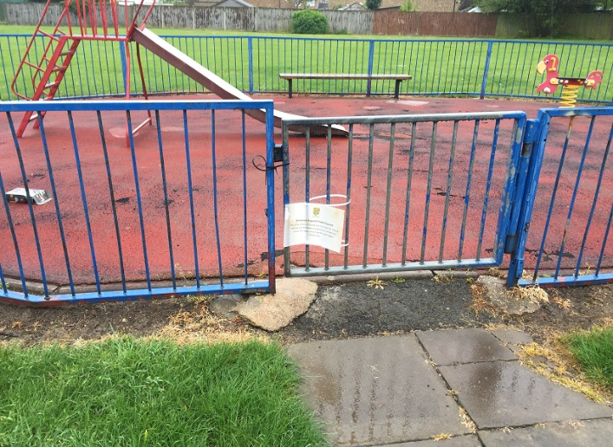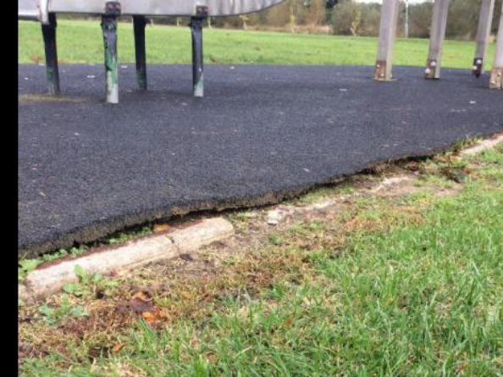
After
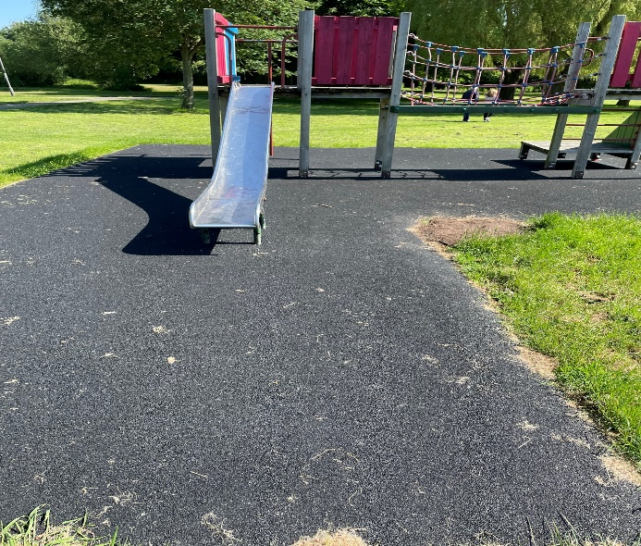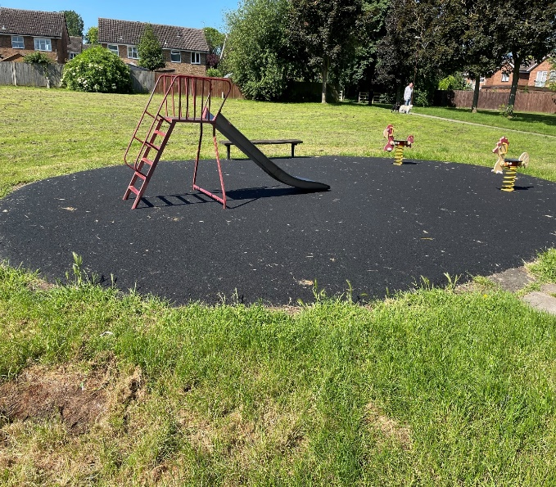

Riverside Meadow
Before
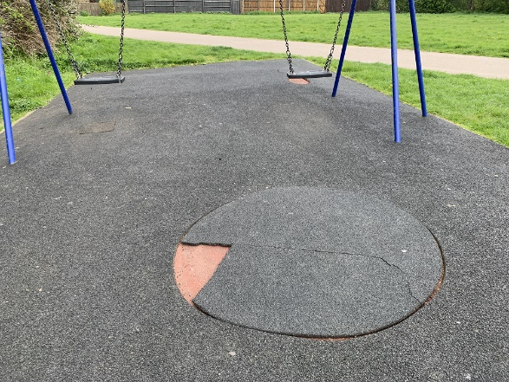
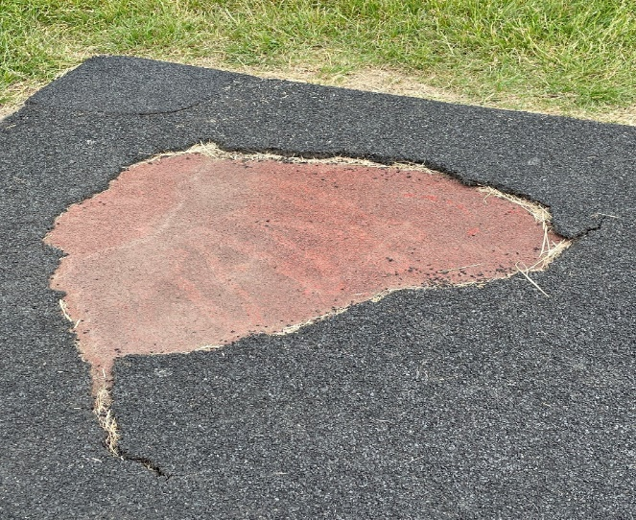
After
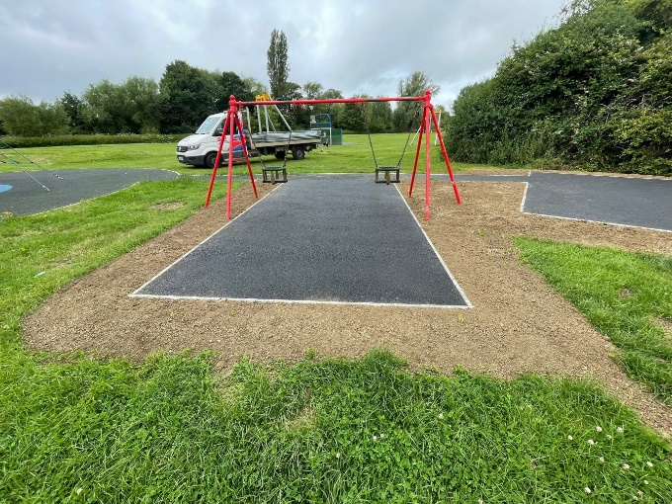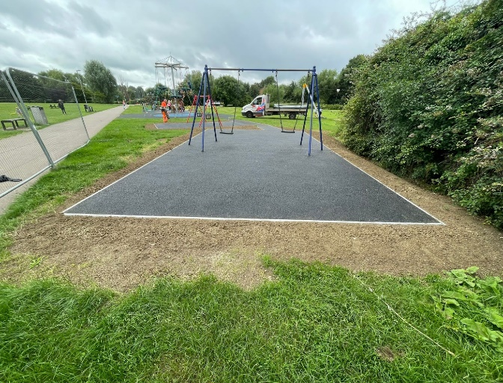

Whitethorns
Before
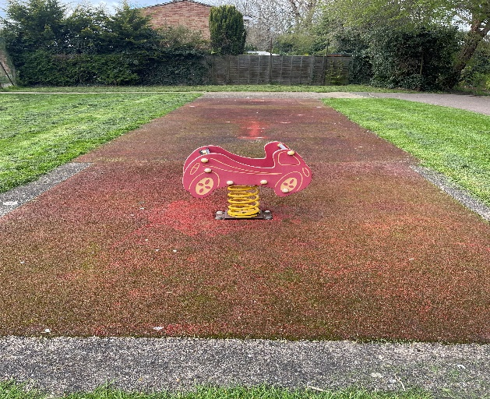
After
